Abnormal excitability of oblique dendrites implicated in an early Alzheimer’s computational model

by

Thomas M. Morse^{1,*}, Nicholas T. Carnevale¹, Pradeep G. Mutalik², Michele Migliore^{1,3}, and Gordon M. Shepherd¹

¹Department of Neurobiology,²Center for Medical Informatics,
Yale University School of Medicine
New Haven, CT, USA.
³Institute of Biophysics, National Research Council
Palermo, Italy

Correspondence:

Dr. Tom Morse
Department of Neurobiology
Yale University School of Medicine
P.O. Box 208001, New Haven CT 06520-8001
tom.morse@yale.edu

Running title: Oblique dendrite susceptibility to aβ
Abstract
The integrative properties of cortical pyramidal dendrites are essential to the neural basis of cognitive function, but the impact of amyloid beta protein (aβ) on these properties in early Alzheimer's is poorly understood. In animal models, electrophysiological studies of proximal dendrites have shown that aβ induces hyperexcitability by blocking A-type K⁺ currents (I_{A}), disrupting signal integration. The present study uses a computational approach to analyse the hyperexcitability induced in distal dendrites beyond the experimental recording sites. The results show that back-propagating action potentials in the dendrites induce hyperexcitability and excessive calcium concentrations not only in the main apical trunk of pyramidal cell dendrites, but also in their oblique dendrites. Evidence is provided that these thin branches are particularly sensitive to local reductions in I_{A}. The results suggest the hypothesis that the oblique branches may be most vulnerable to disruptions of I_{A} by early exposure to aβ, and point the way to further experimental analysis of these actions as factors in the neural basis of the early decline of cognitive function in Alzheimer's.

Keywords: action potential backpropagation, computer model, electrical activity
1. Introduction
Interest in the pathogenesis of Alzheimer's disease is mainly focused on molecular and biochemical changes underlying degeneration in the cell body and dendrites of cortical pyramidal cells (reviewed in (Anderton et al., 1998, Lue et al., 1999)). Relatively little attention has been given to the dendrites with regard to disruptions of intrinsic electrical properties related to their information processing mechanisms (reviewed in (Byrne, 2009)), yet these are recognized to be essential to the neural basis of cognitive function.
Critical experimental evidence for a negative impact on these mechanisms in animal models of Alzheimer's has been obtained in dual patch recordings in rat hippocampal tissue slices, in which aβ blocked A-type K⁺ channels (I_{A}) in pyramidal cell dendrites, causing an increase in dendritic membrane excitability as shown by enhanced back-propagating action potentials (bAPs) (Chen, 2005). This aβ block of I_{A} has been confirmed in dissociated (Xu et al., 1998) and cultured (Zhang and Yang, 2006) hippocampal CA1 neurons and in cholinergic basal forebrain neurons (Jhamandas et al., 2001) and neocortical neurons (Ye et al., 2003). bAPs are believed to be critical for information processing and memory storage by cortical pyramidal neurons and their cortical microcircuits (Gasparini et al 2007; Stuart et al., 2008). Disruption of bAPs can therefore be a sensitive indicator of negative effects of aβ on signal processing involved in cortical function.
These effects on bAPs are likely to occur mainly in the distal branches of the apical and possibly basal branches, where most of the integrative activity of the neuron occurs, which poses a difficult challenge to electrophysiological analysis. We have therefore utilized a realistic computational model of the hippocampal pyramidal neuron to analyze dendritic bAPs under K⁺ channel block in closer detail. The simulation results go beyond the experimental findings, providing evidence that the fine oblique branches of the apical dendritic tree are especially vulnerable to the increased excitability and disruption of the bAP due to the K⁺ channel block by aβ.    This suggests that disruption of dendritic signalling in otherwise normal cells may underlie the earliest cognitive impairments in AD.
How might these changes in dendritic signalling be related to the subsequent degenerative changes in AD? The calcium hypothesis proposes that long-term changes in Ca²⁺ signaling lead to the degenerative changes (Khachaturian 1987, see review in Stutzmann 2007). Good and Murphy (1996) and Chen (2005) suggested that the raised excitability of the cell due to I_{A} block increases Ca2+ influx which can lead to excitotoxicity and degenerative changes. Our computational model is designed to assess a possible link between the dendritic action potentials and their ability to stimulate Ca²⁺ currents at different points in the dendritic tree. The simulations provide a novel insight into the relation between backpropagating action potentials and Ca²⁺ currents at different dendritic sites, pointing especially to the sensitivity of Ca²⁺ currents in the oblique dendrites to the I_{A} block. The results are of further interest in relation to the finding that oblique and basal dendrites are lost first in early Alzheimer’s before the apical tuft and shaft (Scheibel, 1979).

2. Methods
In order to reproduce and extend the results of (Chen, 2005) we drew on several web resources. ModelDB is a web-accessible database of curated published neuronal models. Of over 500 models now available at this site, some dozen << MULTIPLE DOZENS!>> are of CA1 pyramidal neurons, each simulating a representative cell under a set of physiological conditions. To evaluate the effects of aβ, we started with one of the models by (Migliore et al., 2005) (ModelDB accession number 55035) that have morphologies and physiological properties similar to those of the cells illustrated in the study of (Chen, 2005). The model we selected had basic membrane properties (see Table 1) that are robust over cells of this type. Recent experimental evidence indicates that membrane resistance in distal branches may be significantly lower than the values used in the ModelDB entry (see references << we should cite these directly, not by proxy >> in (London et al., 1999, Omori et al., 2006, Omori T, 2009)). Consequently we updated the model by reducing Rm to 10^{3.5} Ohm cm2 at distances > 350 microns from the soma.This shifted the envelope of peak bAP amplitude about 100 microns toward the soma in both the control and aβ applied cases.

Dendritic maximum conductances and membrane parameters | Value(s). Note: d is distance from soma
g_{Na} | 0.25 nS/μm²
g_{K} | 0.1 nS/μm²
g_{KA} | 0.03 * (1 + scale_{ka}*d/100)+K_{boundary} nS/μm²
scale_{ka} | 3 (obliques), 1 (non-oblique dendrites)
g_{H} | 0.00005*(1+3/d) nS/μm²
R_{M} | 10^{4.5} (d<350 μm), 10^{3.5} (d>350) ohm cm²
C_{M} | 1 μF/cm²
g_{L} | 0.001 nS/μm²
g_{N} | 0.001 nS/μm²
g_{T} | 0.00025 nS/μm²
G_{Ca,K} | 0.0005 nS/μm²

Table 1. The basic set of dendritic maximum conductances and membrane properties in the modified (Migliore et al., 2005) model. The set of constants, K_{boundary,} are 0 on the apical trunk and set so that g_{A}(d) in the obliques are “continuous” from the trunk onto each oblique. The last four conductances were only present in simulations that examined calcium effects. The axon (no I_{A}) and soma (I_{A} with different kinetics in soma and proximal dendrites) have other simple distributions. See model code in ModelDB and (Migliore et al., 2005) for details. We recommend NEURON's ModelView tool for viewing the spatial distributions of these and other parameters (Hines et al., 2007).

We used an updated I_{A} distribution that increases linearly with distance from the soma, in which the slope of the maximum conductance is three (3) times as large in the oblique branches as along the apical trunk (consistent with experiments by (Frick et al., 2003, Gasparini et al., 2007))(Table 1). This has the effect of making I_{A} densities at distal ends of obliques similar to the densities at distal ends of apical tuft branches. It may be noted that none of the current pyramidal cell models includes representation of dendritic spines. For present purposes these can be considered as increasing the surface-to-volume ratios in Fig 6 (see for example, Katz et al, 2009), but would not affect the basic conclusions.
The effect of aβ on the model neuron was simulated by a reduction of the transient A-type potassium (K⁺) maximum conductances, g_{KA}. While there are likely other properties affected by aβ, this was the only one monitored in the experiments of (Chen, 2005), and the only one tested in our study. The simulated aβ effect was modeled by reducing g_{KA} by the average amounts, 47% and 32%, that (Chen, 2005) measured in control and 1 µM aβ applied excised patches from CA1 pyramidal neuron dendrites and somas, respectively. This caused a similar enhancement of the amplitude of the bAP at a distance on the apical dendritic trunk corresponding to the site in the labeled cells in the experiments of (Chen, 2005). We performed additional numerical experiments with simulated 0.2 µM and 0.5 µM aβ and also aβ applied to dendritic subsets, e.g. just the obliques, or just the distal tuft.
To study effects of aβ on internal calcium concentration we added calcium channels and a calcium accumulation mechanism. We used L,T, and N-type Ca²⁺ channels from the files associated with the publication Hemond et al. 2008 which were available in ModelDB. The kinetics of these channels were derived from Jaffe et al. 1994. Conductance density ratios were the same as those
used by Song et al. 2002 who based their calculation on the measurements of Fisher et al. 1990. More details on the anatomical distribution of these channels have been published (see review in Oh et al. 2010); however, electrophysiological measurements taking these new results into consideration have not been published. Conductance densities were adjusted so that a bAP produced a rise of about 200nM [Ca2+]i in a proximal apical dendritic compartment to be consistent with experimental values (Liao and Lien 2009, Helmchen et al. 1996, Maravall et al. 2000). For the purpose of these simulations of the effects of bAPs on membrane Ca²⁺ fluxes we omitted NMDA receptors and calcium induced calcium release (CICR) from internal stores.
All simulations were performed with NEURON (Hines and Carnevale, 1997); model source code is available from ModelDB under accession number 87284.

3. Results
We first used our model to reproduce the experimental results of (Chen, 2005) for the normal mouse CA1 hippocampal pyramidal cell. Depolarizing current injected in a simulated axon caused the initiation of an action potential (the same protocol that (Chen, 2005) used) which backpropagated along the axon, into the soma, and then further backpropagated into the dendrites. As shown in Fig. 1 (B), with simulated patch recordings at the soma and at a site 264 µm from the soma on the apical dendritic trunk, the responses closely resembled those shown in Fig. 1A of (Chen, 2005), with a large amplitude spike in the soma, and a lower amplitude spike 280 µm from the soma in the dendritic trunk. The differences between the simulations and experiment are examined further in the Discussion. Action potentials are shown in traces recorded from an oblique’s distal tip in the simulation (far right of Fig. 1 B); experimental recordings of membrane potential near the distal terminations of oblique dendrites have not yet been reported in normal or Alzheimer’s animal models.
Spike attenuation with increasing distance from the soma in the normal dendrite has been previously reported (for example (Spruston et al., 1995, Hoffman et al., 1997, Johnston et al., 1999, Acker and White, 2007, Gasparini et al., 2007)). Backpropagating dendritic spike amplitudes in CA1 pyramidal cells in vitro usually fall into two groups; at 300 µm 26-42% attenuation (9/20 cells) and 71-87% attenuation (10/20 cells) (Golding et al., 2001). Only weakly propagating bAPs (i.e. strongly attenuating) CA1 pyramidal neurons have been observed in vivo (Kamondi et al., 1998).
As noted by (Hoffman et al., 1997), I_{A} channel density increases with distance from the soma into the apical dendritic field, shunting and progressively reducing the peak amplitude of the invading action potential ((Migliore et al., 1999); see also reviews in (Gulledge et al., 2005, Sjostrom et al., 2008)). This implies that the most distal apical dendritic branches are normally not subjected to a strong depolarization by the bAP, which is explored further below.

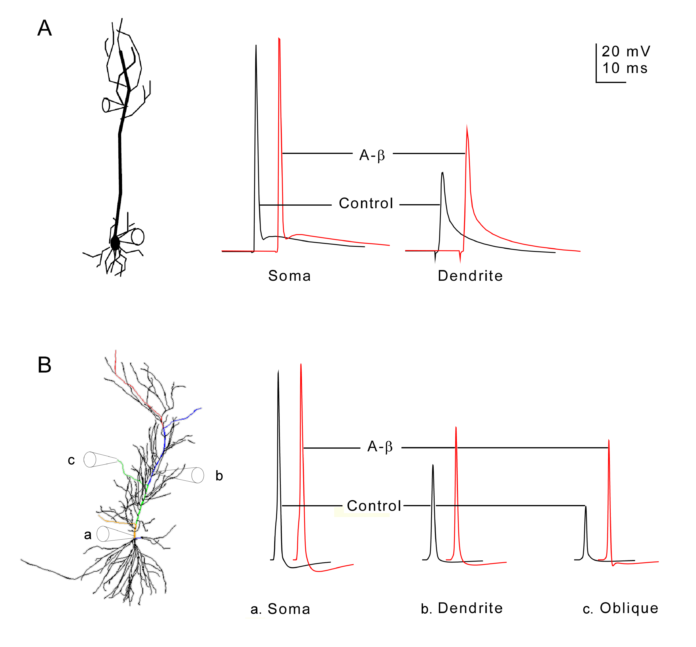

Fig. 1. (A). Identified CA1 neuron with soma and primary dendritic spike recordings (modified from (Chen, 2005) to transform recordings to the same scale bars; red color indicates the aβ applied condition). The voltage traces were recorded at the soma and the primary dendrite 280 ums from the soma. (B). Morphology and simulated recordings from our CA1 pyramidal neuron model . Several labeled paths through the cell have voltages displayed in Fig. 3 and the supplemental movie: from the soma to the most distal tuft (red), a distal oblique (blue), a middle oblique (green), and a proximal oblique (tan) dendrite. These paths overlap along the primary trunk.

The left side of Fig. 1B uses cartoons of "electrodes" to indicate the positions in the model from which the << "simulated" is getting more than a bit repetitious by now >> voltage traces on the right side of Fig. 1B were recorded. The primary dendrite recording location was 264 ums from the soma.
As described in Methods, << drop sentence two--already said that in the previous paragraph >> the effect of aβ was simulated by reducing I_{A} conductance by the amounts reported by Chen (2005). This increased somatic spike amplitude in the model by 4.7 %, and enhanced the back-propagating primary dendritic spike by 40 % at a distance of 264 microns from the soma (Fig. 1B). This was near the average values observed by Chen: 3.1 ± 1.3% increase in the soma and 33.9 ± 6.1% increase in the primary dendrite 240-300 microns from the soma. The enhancement of dendritic spike amplitude was shown experimentally to be due to the block of a transient I_{A} current, a result in line with previous studies (see for example (Hoffman et al., 1997, Migliore et al., 1999, Watanabe et al., 2002)) that examined bAP amplitude with blocked transient I_{A} current. The model supports this result by showing that the partial block of the I_{A} current is sufficient to enhance the bAP, and that other reported excitatory effects of aβ, such as the longer time course increase in L-type Ca currents (Ueda et al., 1997), which likely contributes to the excitability of the dendrites, are not necessary to produce enhanced bAPs.

3.1 Backpropagating action potentials in the dendritic tree
An advantage of the model was that it could be used to explore properties of any part of the dendritic tree that might be affected by aβ reduction of I_{A} conductance. In particular, we were interested in thin dendritic branches which to our knowledge have not been recorded from in animal models of Alzheimer’s, but which we postulated might be especially vulnerable to aβ effects.
We first analyzed the invasion of the bAP throughout the entire extent of the modeled apical dendritic tree. As shown in Fig. 2 this involved the distal two-thirds of the dendritic tree beyond the recording site of (Chen, 2005). Following the method of (Migliore et al., 2005) and others we displayed the peak action potential in each compartment of the cell as a function of linear distance (through the processes of the cell) from the soma (Fig. 2). The control for invasion of the bAP (black oblique dendrites, purple trunk, green tuft) shows that the spike had a large amplitude at the soma, with the amplitude reduced midway into the dendrites, as in the recordings in Fig. 1. This result is consistent with weakly propagating bAPs as seen in vivo (Kamondi et al., 1998). In normal pyramidal cells, this shows, surprisingly, that the bAP causes little depolarization of the most distal branches. By contrast, with reduction of I_{A}, the amplitude of the bAP was largely maintained into the terminal oblique branches (red). There was even a 62 mV depolarization into the most proximal region of the effected distal apical tuft branches (tan), whereas in the control there was a small (20 mV at the proximal end of purple trunk) depolarization (green). The distal ends of the apical tuft had less than 20 mV depolarizations in both the control and aβ applied cases (far right of Fig. 2)

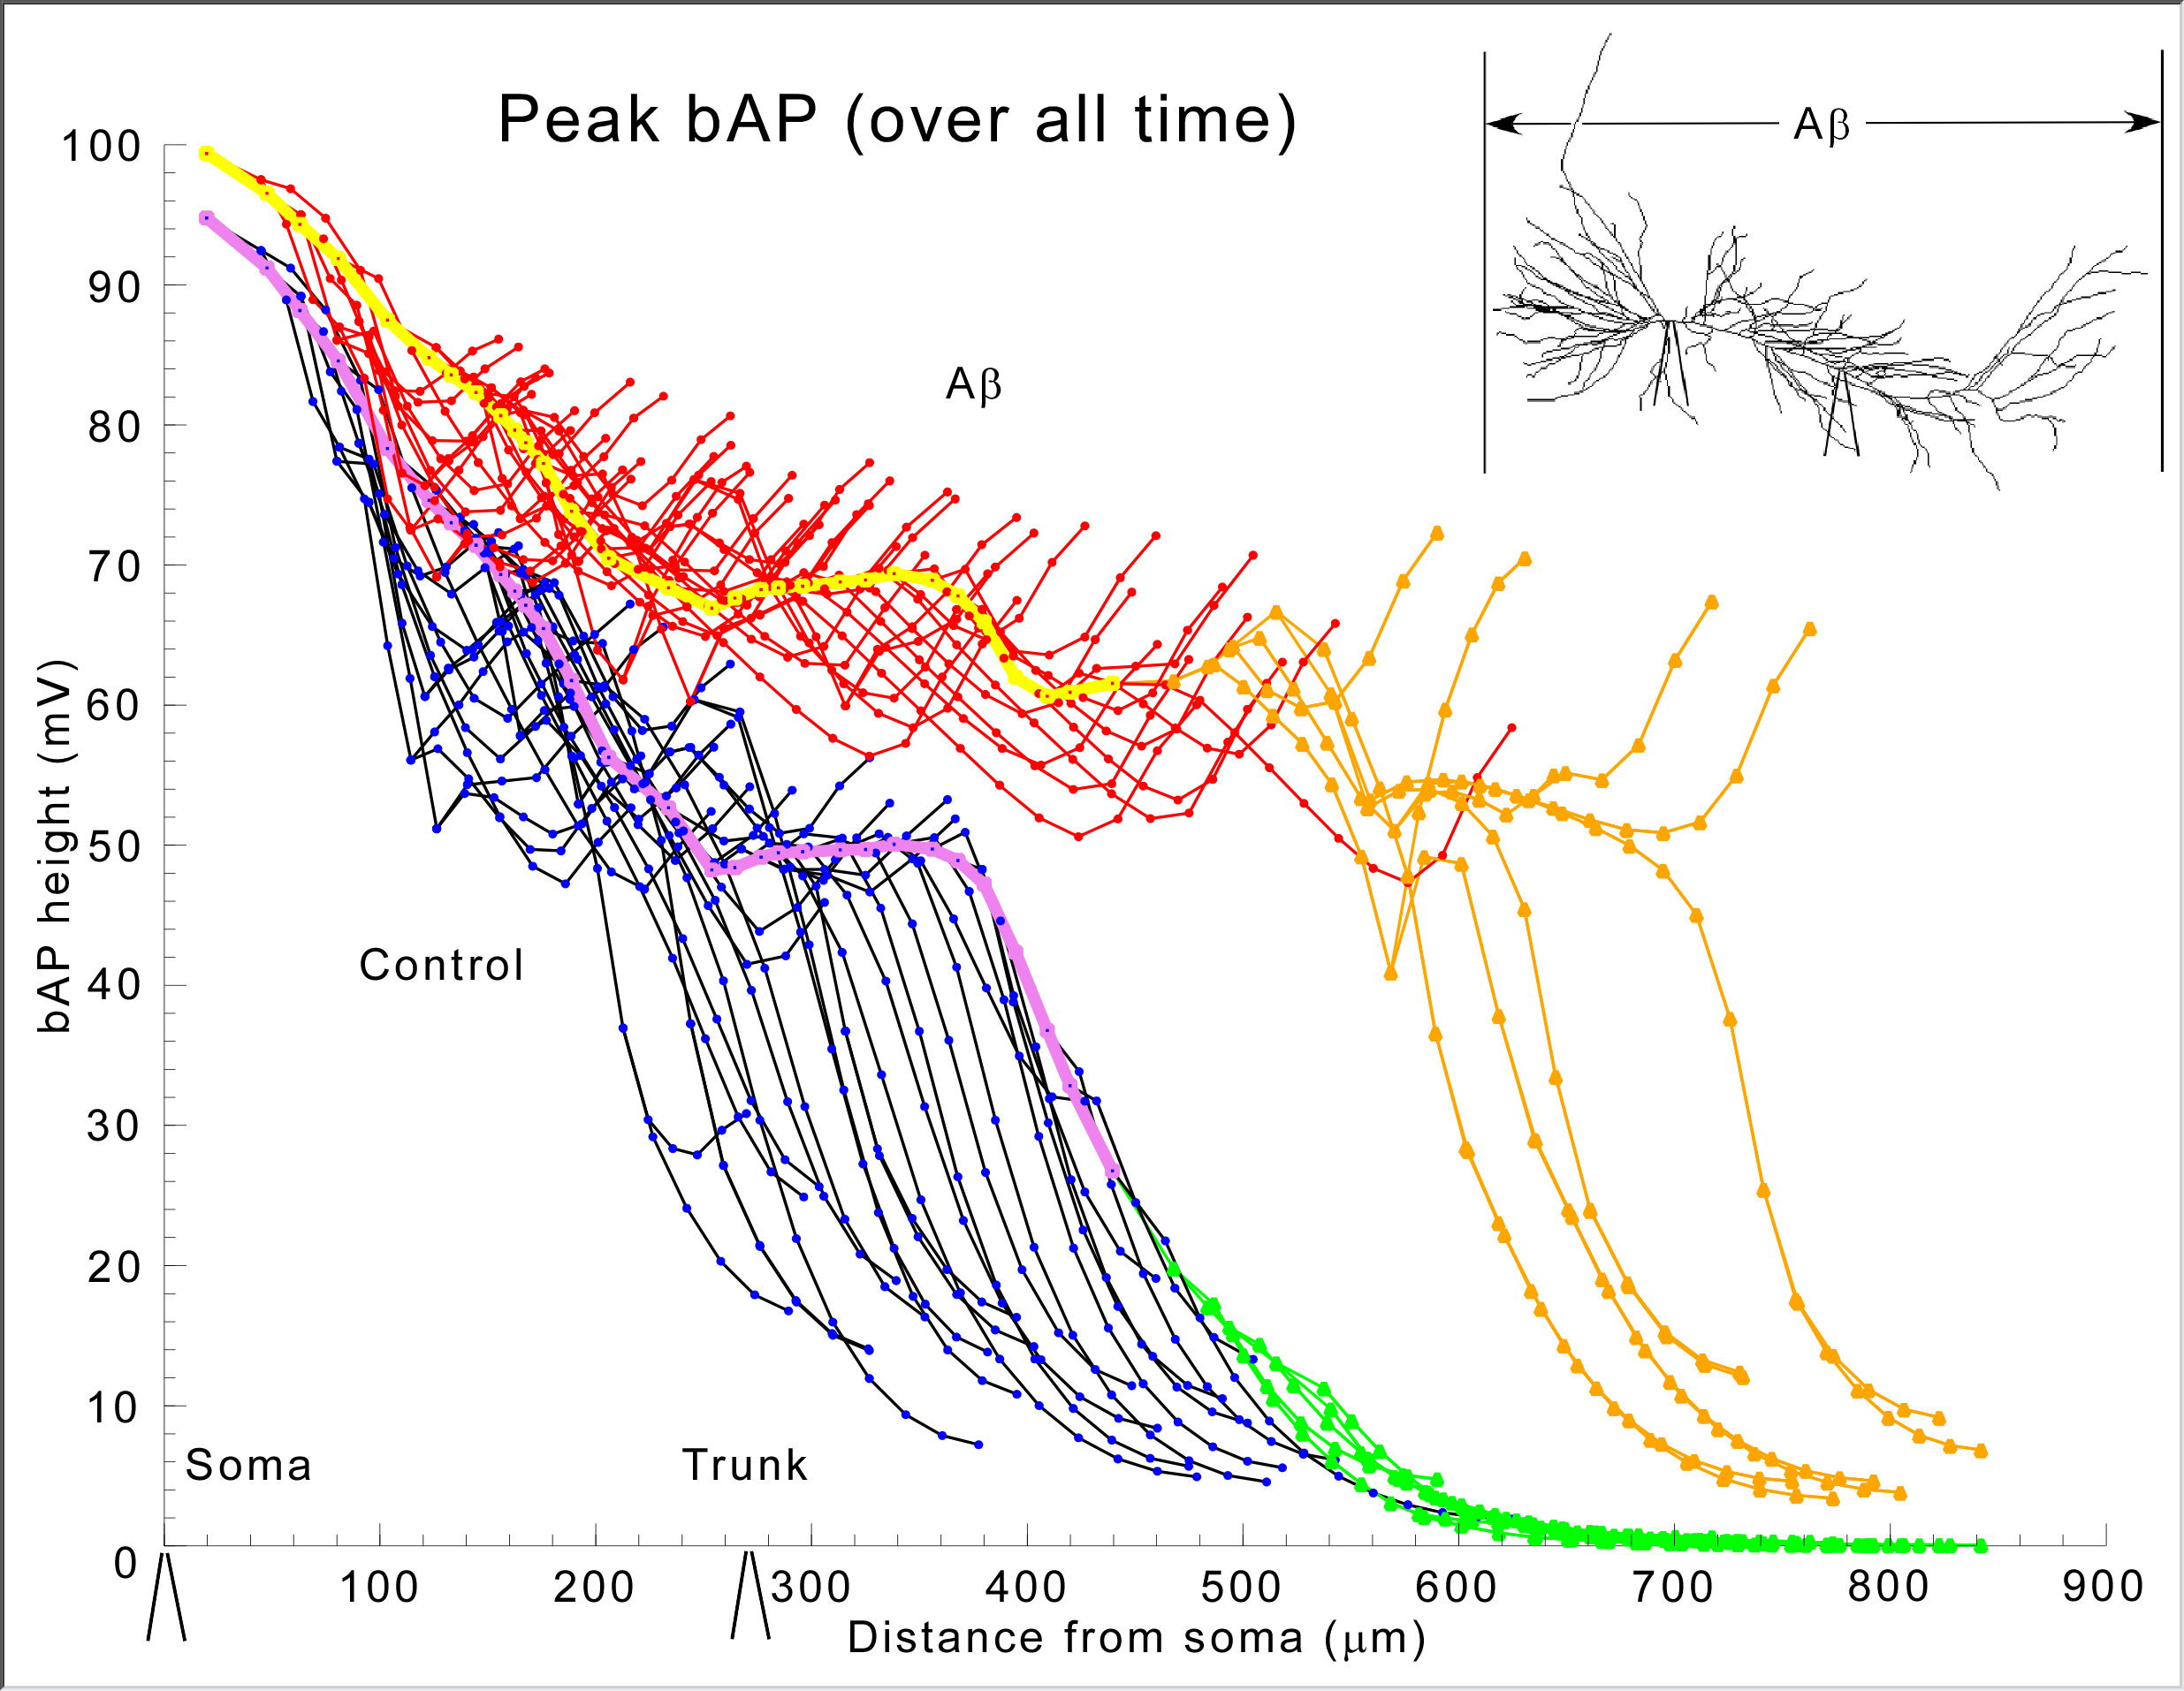

Fig. 2 Simulated pyramidal neuron bAP amplitude peaks in apical dendritic compartments as a function of distance from the soma. The simulation was run twice, first under normal conditions: black-oblique dendrites, purple-trunk, green-apical tuft, and second with 1 µM aβ applied: red-oblique dendrites, yellow-trunk, tan-apical tuft. (Chen, 2005) recording sites at the soma and within 11% of 270 microns (actual range 240-300) along the primary dendrite are indicated below the x-axis. The inset shows that aβ was applied ubiquitously and shows equivalent locations (soma and 270 microns along primary dendrite) of the experimental recording electrodes on the model cell, which are also shown along the x axis in this and subsequent appropriate figures to give a sense of scale.

We next analyzed the extent of bAP invasion in individual dendritic branches. A single frame from a movie, Fig. 3 depicts the voltage throughout the cell at an instant of time about 2 ms after the AP has peaked at the soma. The movie (available in Supplementary Data and on the website for the CA1 pyramidal neuron in BrainPharm) shows the entire period of invasion of the bAP. The depolarizations in individual branches in the right panels are indicated in color coding and the instantaneous voltages along indicated paths (see Fig. 1 B left panel and supplementary Fig S2 for details) are shown in the left panels. The bAPs in the Alzheimer model cell (bottom panels) distal dendrites have substantial amplitudes (lower left), -15 mV peak, while in the normal cell the bAP is nearly extinguished, -47 mV peak, (upper left). From the results in Figs. 2 and 3 it appears that an intense depolarization occurs in the most distal parts of the oblique branches when K⁺ channels in the entire tree are uniformly blocked, as by exposure to aβ.

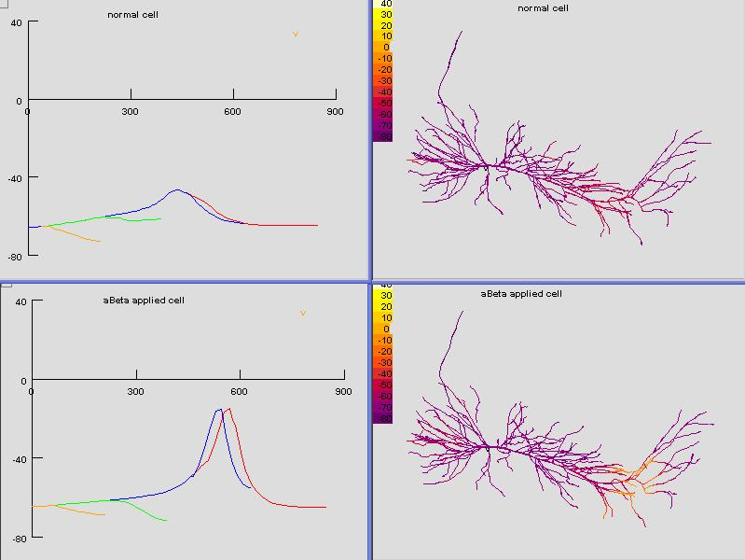

Fig. 3 Movie frame of aβ applied (top) and healthy (bottom) simulations 2 milliseconds after the spike peaks in the soma. On the left are plots of the instantaneous voltage (y-axis (mV)) for points along paths (x-axis (µm)) from the soma (0 µm) to a distal dendritic tuft compartment (849 µm) and oblique dendrites (see Figure 1B left for each left-panels colored path’s anatomical location). On the right panels are color-coded voltage amplitudes throughout the spatial extent of the cell. At this instant the bAPs are continuing to propagate during invasion of the aβ-applied cell's distal dendrites, while in the normal cell the bAP is extinguished. The movie is available in the online supplementary material.

3.2 Differential vulnerability of different parts of the dendritic tree
Given the enlarged view of the entire dendritic tree afforded by the model, we were able to test the hypothesis that different parts of the dendritic tree might be differentially sensitive to the aβ block of the bAP. To test this hypothesis we carried out two types of computational experiments. The first was to reduce stepwise I_{A} to simulate different concentrations of globally-applied aβ from 0 to 1 µM (cf. (Chen, 2005)), to test for a possible threshold for the effect on the bAP. As shown in Fig. 4, with decreasing degrees of global I_{A} block there was a graded decrease in the amplitude of the simulated dendritic action potential, and a corresponding decrease in amplitude of the depolarization in the oblique and most distal apical dendrites. The effect was graded with amount of I_{A} block; there was no evidence of a nonlinear threshold effect of the amount of block on the bAP.

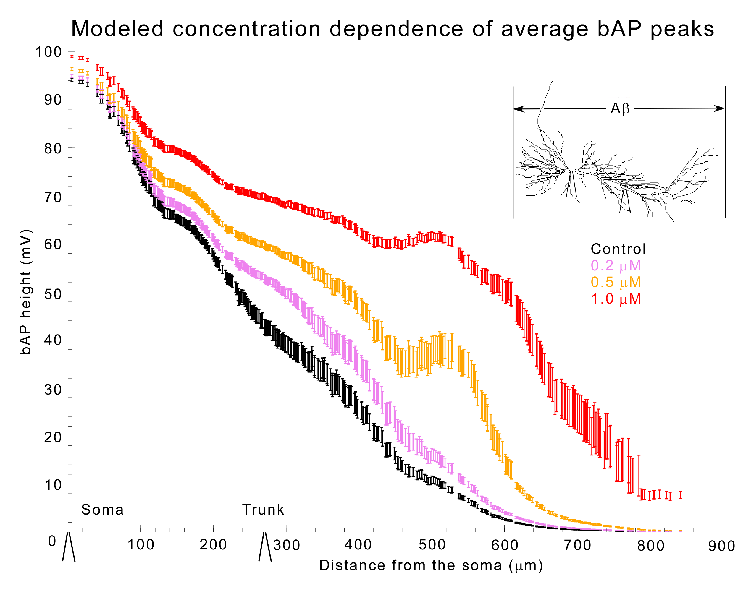
Fig. 4 Graded effect of global (uniform) aβ concentration on bAP. The peak bAPs are averaged over dendritic compartments sharing similar length paths to the soma (in moving bins of 50 µm width) and have their standard error of the mean calculated. These bins are centered at each dendritic compartment with the peak bAP average itself unmarked at the center of each bin’s bar. Normal cell black, modeled 0.2 µM purple, modeled 0.5 µM tan, 1 µM red. The normal (black) and 1 µM (red) correspond to the data in Fig. 2. See Fig. 2 for inset description and electrode locations.

The second type of model experiment was to apply the I_{A} block to specific parts of the dendritic tree. We were particularly interested in comparing the effects on the oblique branches, believed to be critically important for learning and memory (cf. (Gasparini et al., 2007)), with the effects on the trunk and distal dendritic branches.
The results showed that the most sensitive sites for effects on the bAP were the oblique dendrites. Reduction of I_{A} in the proximal dendrites, equivalent to local application of 1 µM aβ, resulted in only a slight shift (not shown), similar to the effect of 0.2 µM uniformly-applied aβ (Fig. 4). By contrast, the same I_{A} reduction locally in the oblique dendrites compared to the normal (Fig. 5) caused a heightened local spread of depolarization and also spread of additional depolarization into the proximal portion of the apical tuft. Local I_{A} reduction in only the apical dendritic tuft caused no change (not shown) because the bAP did not invade the tuft in the normal case. In both cases, proximal (between 0 and 100 µm) bAPs and soma APs were least affected (Fig. 5 left part of graph near the soma). These observations make intuitive sense considering that the larger effect of the distal vs. proximal reductions in I_{A} was correlated with the increasing density of I_{A} channels with distance from the soma, as well as with the decreasing diameters of the branches.

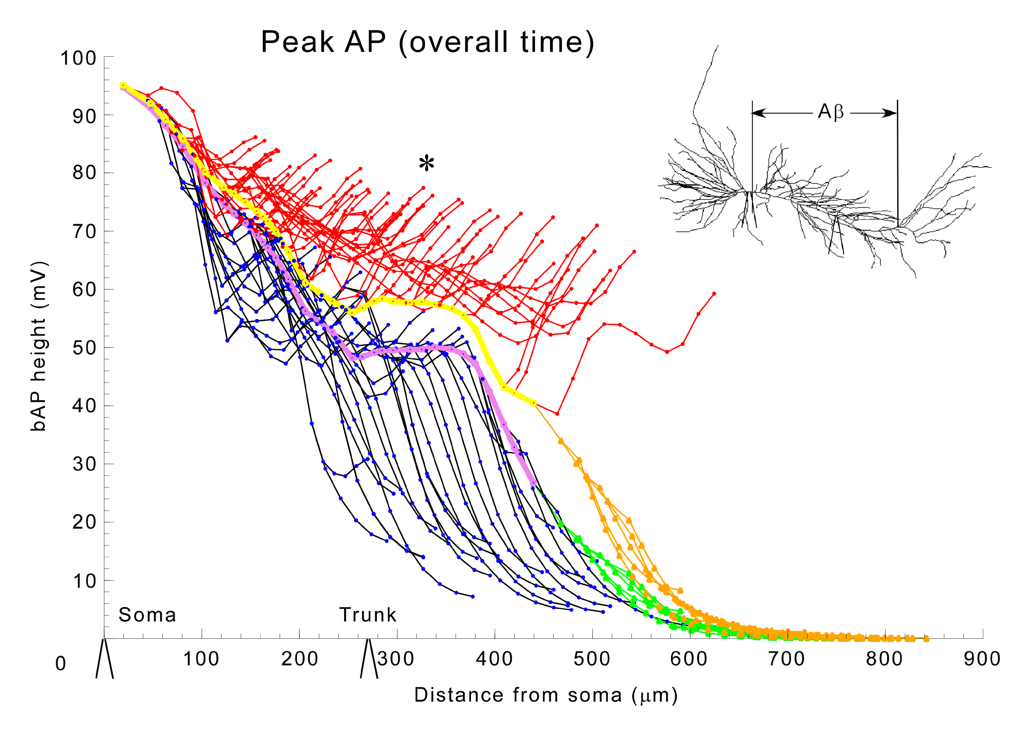

Fig. 5 Local effects of aβ on bAP. Normal: black-oblique dendrites, purple-trunk, green-apical tuft; 1 µM applied only to oblique dendrites: red-oblique dendrites, yellow-trunk, tan-apical tuft. Asterisk indicates abnormally large amplitude in the oblique dendrites. The inset shows that aβ was applied only to the oblique dendrites. (See Fig. 2 for electrode locations)

3.3 Simulations suggest obliques may be vulnerable to producing peaks in [Ca^{2+]}_{in}
Given the sensitivity of the oblique dendritic branches to the effect on bAPs of the K⁺ channel block, we wished to test the hypothesis that they would be correspondingly sensitive to increased Ca²⁺ influx. To test how aβ might affect Ca²⁺ influx and concentration elicited by bAPs, we added calcium channels and a calcium accumulation mechanism as described in Methods. First we examined maximum [Ca²⁺ _{i} elicited by a backpropagating spike as a function of location along four paths in the apical dendritic tree (Fig. 6A). One path ran from the origin of the primary apical trunk to the distal end of a dendrite in the apical tuft (thick black line), and the other three ran along oblique branches that arose from the apical trunk in the proximal, intermediate, or distal zones of stratum radiatum (thick red, blue and violet lines).
The plots of maximum [Ca²⁺]_{i} vs. distance along these paths are shown in Fig. 6B under normal and aβ conditions. Under normal conditions (thin traces), maximum [Ca²⁺]_{i} had a peak near the proximal end of the primary apical trunk (point 1 in Fig. 6B), but decayed more or less steadily with increasing distance out to the end of the apical tuft. This is similar to the spatial distribution of Ca influx associated with the bAP in the experiments of Gasparini et al (2007). Smaller peaks appeared in the proximal and intermediate obliques reflecting the diminishing amplitude of the bAP.
The effect of aβ (Κ+ block) was to cause a large increase of maximum [Ca²⁺]_{i} almost everywhere (thick traces in Fig. 6B); only the most distal part of the apical tuft (>700 µm) seemed unaffected. The increase was disproportionately large in the obliques, especially near their origins from the apical trunk. The locations of peaks, and of the valleys that separate them, are marked in Fig. 6A by red diamonds and blue circles, respectively. Note that each peak is near the proximal end of a branch, and each valley is near the distal end of that branch's parent. It is also noteworthy that aβ (Κ⁺ block) does not affect the positions of these features in space.
The factors that produced these [Ca²⁺]_{i} profiles were identified in the model (see Legend for details). First was maximum Ca2+ membrane current activated by the bAP, as shown in 6D. Second was the half-width of this transient, reflecting the amount of charge transfered, which rose strongly in the obliques (Fig. 6E). Third was the surface-to-volume (svr) ratios which increased abruptly with bAP invasion of the thin oblique branches. These three factors multiplied together produced the profiles in 6C, which can be seen to correlate closely with the actual values for maximum [Ca²⁺]_{i} produced by the bAP in 6B. In summary, bAP invasion of the oblique dendrites produces large increases in [Ca²⁺]_{i}, particularly in those nearer the soma.
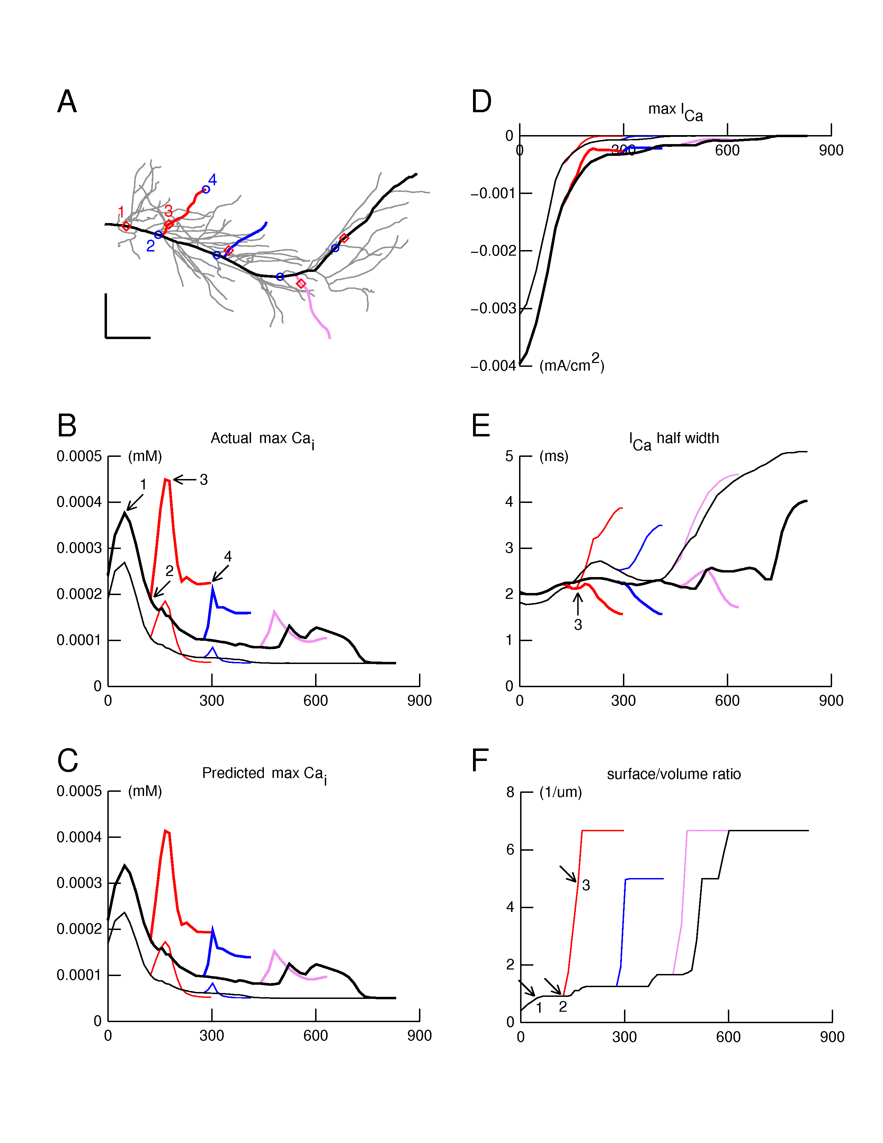

Fig. 6. The spatial profile of [Ca²⁺]_{i} elicited by a backpropagating action potential in the apical dendritic tree was examined along four paths indicated in panel (A) by thick lines: primary apical and apical tuft (black); proximal, intermediate, and distal obliques (red, blue, or violet). Panels B-F show simulation results plotted as functions of distance along these paths, using thin and thick lines for normal and aβ (K+ block) responses, respectively. (B). Maximum [Ca²⁺]_{i} shows a declining trend with distance which is interrupted by peaks and valleys. aβ (K⁺ block) increases maximum [Ca²⁺]_{i} but does not affect the locations of the peaks and valleys. (C). The maximum [Ca²⁺]_{i} in B is closely predicted by this graph showing the product I_{Ca}_amplitude*I_{Ca}_halfwidth*svr. (see D-F) (D). I_{Ca} amplitude falls off more or less steadily with distance. Its spatial profile along the path from apical tree origin to termination in the distal tuft is similar to that of maximum [Ca²⁺]_{i}. However, I_{Ca} amplitude does not account for the peaks of maximum [Ca²⁺]_{i} near the proximal end of the apical trunk, in the obliques, or (in the presence of aβ) in the branches of the apical tuft. (E). Spatial variation of I_{Ca} half width. The arrow marks the location of the peak of maximum [Ca²⁺]_{i} in the proximal oblique. Note the absence of any sudden or large change that could account for the peaks of maximum [Ca²⁺]_{i} observed anywhere in the model under normal or aβ conditions. (F). Surface/volume ratio as a function of distance along the paths. The arrows mark positions that correspond to points 1, 2, and 3 in Fig. 6A and B. The large jumps in svr happen at branch points, and encompass the locations of peaks in the spatial profile of maximum [Ca²⁺]_{i}.

.

4. Discussion
The simulation results reported here support the experimental results (Chen, 2005) that a selective effect of aβ on K⁺ currents increases the extent of invasion of action potentials from the cell body into the apical dendritic trunk of CA1 pyramidal neurons, as has also been seen with pharmacological blockade of the A-type K⁺ current (Hoffman et al., 1997). In both the experiments and the model the effect involved a moderate increase in spike amplitude in the trunk region. The simulation results provide new evidence that aβ would have its most sensitive effect on the bAP in the oblique dendritic branches.
In the thin and most distal branches of the oblique dendrites the invading bAP maintained a large amplitude, whereas in the normal control the depolarization decayed rapidly. There was thus a much larger difference between the depolarizations in the aβ and normal case in the distal oblique branches compared to the dendritic trunk. Building on previous studies of I_{A} blocked (starting with (Hoffman et al., 1997)), the results show for the first time that the effect of a disruption of normal dendritic electrical activity by I_{A} blockade appears to be more severe in the small branches than other dendritic locations. This would potentially have marked effects on both dendritic information processing, as well as Ca²⁺ excitotoxicity induced by the excessive depolarization (Good and Murphy, 1996).
To analyze this further, we carried out simulations of localized A-type potassium channel block to model the effect of local applications of aβ to different parts of the tree. The local application to the dendritic trunk had relatively little effect on the amplitude and extent of invasion of the bAP. In contrast, local application to the thin oblique dendrites caused large local bAPs and spread to the tuft.
The prediction from these results is that the early aβ pathology in CA1 hippocampus would have its earliest and most sensitive effects on the thin oblique dendrites of the pyramidal cells there. This may be significant for several reasons. First, the back-propagating action potential is an important property in the normal function of the pyramidal neuron. It is believed to play a key role in learning and memory, through its depolarizing actions which signal to the dendrites that a particular combination of synaptic inputs has been sufficient to generate an axonal spike output of the neuron. One possible function of the bAP is to relieve the Mg²⁺ block of glutamatergic NMDA receptors. This depolarization is presumed to affect the readiness of NMDA receptors to be involved in activity-dependent mechanisms believed to underlie learning and memory. Experiments (Kamondi et al., 1998, Canepari et al., 2007) and our results have implications for this normal model, because they indicate that it is unlikely that the bAP significantly depolarizes the most distal dendritic tuft. Significantly, this distal region of the pyramidal cell dendritic tree appears to be more involved in the control of NMDA receptors by local synaptic depolarizations than by the bAP. Oblique dendrites on the other hand appear to be under control of both. It is likely that when synaptic background and/or normal network activity is added to the model the distal tuft will be partially depolarized by bAPs.
With regard to links between the bAPs and degenerative changes, a previous single compartment model (Good and Murphy, 1996) calculated changes in [Ca^{2+]}_{i} with respect to simulated increases in aβ. Comparisons between their work and ours are difficult because it is not clear which compartment their single compartment model should be compared to (the soma, proximal apical, oblique dendrite, etc.). Chen (2005) reported calcium dye recordings in the apical dendrite in aβ treated slices. To our knowledge, there are no publications that have measured calcium concentration changes with the application of aβ to the spatial extent of the dendritic tree of a CA1 pyramidal neuron. The model points to the need for experiments in animal models of Alzheimer's to test these predictions and hypotheses.

4.1 Suggested experiments
We suggest repeating the kinds of experiments that (Chen, 2005) performed on the primary dendrite on the oblique dendrites to examine if they are more susceptible to large bAPs with I_{A} block by aβ. These experiments are technically very challenging due to the small diameter of the obliques. We are only aware of one report of electrode voltage recordings in oblique’s; (Kamondi et al., 1998) made in vivo patch electrode recordings from hippocampal CA1 pyramidal neuron dendrites and somas. They were able to record from the middle of (at least one) oblique dendrite in vivo (see their figure 3). Others have recorded calcium dye activity in the obliques (complete obliques in (Canepari et al., 2007) figure 5FG, and locations in the proximal half of obliques in (Gasparini et al., 2007) and (Losonczy et al., 2008)). We suggest repeating any of these methods in animal models of Alzheimer’s (either with transgenic animals or acute application of aβ) to assess the electrical and calcium excitotoxicity vulnerability of the oblique dendrites relative to other cell areas such as the primary apical dendrite and soma.
The identification of the potassium channel subunit gene Kv4.2 underlying the A-type channel in CA1 pyramidal neurons (Kim et al., 2005) has allowed some details of I_{A} activity in determining synaptic kinetics and weights to be illuminated. The Kv4.2 channels are involved in regulatory interactions with the NMDA receptor subunits (Jung et al., 2008). By comparing dominant negative pore mutants of Kv4.2 to uninfected or enhanced Kv4.2 with GFP infected CA1 pyramidal neurons in organotypic cultured slices, support was found for the notion that I_{A} is a negative regulator of synaptic NMDA currents and evidence was found that the activity of I_{A} apparently regulates the ratio of NR1 to NR2B subunits present in synaptic NMDA receptors (Jung et al., 2008). Furthermore the Kv4.2 A-type K⁺ current has previously been shown to be necessary for normal distant dependent scaling where the amplitude of unitary Schaffer collateral inputs increase with distance from the soma (e.g. (Magee and Cook, 2000)) and interestingly, that NMDA activity in turn regulates the expression of I_{A} (Losonczy et al., 2008). It has been shown that the genetic deletion of Kv4.2 in CA1 pyramidal neurons eliminates this distant dependent scaling and increases the GABA current to these cells (Andrasfalvy et al., 2008). Experiments comparing normal to Alzheimer animal models could test the ratio of NR2A/NR2B and also distant dependent scaling to see if consistent with the changes expected from the presumed aβ block of I_{A} (the changes should be in the direction of those associated with Kv4.2 deletion experiments). These experiments could test the hypothesis that I_{A} block is a path of neurodegeneration in Alzheimer’s.
Experiments with uncaging glutamate or synaptic stimulation in normal and acute application of aβ slices may be able to test changes in integrative properties of CA1 pyramidal cells. We plan future numerical experiments that would predict the results of these kinds of tests by creating ePSP-spike probability graphs, for example as in figure 2 of Jarsky et al (2005), that could then also be tested.
A class of genetics experiments could test the hypothesis that the I_{A} current plays a pivotal role in the progression of AD. These tests would cross any aβ overproducing mutant mouse (AD model mouse) (e.g. Wang et al, 2003) with a Kv4.2 subunit deleted mouse (Andrasfalvy et al, 2008). If deficits of the AD model mouse were rescued in these double mutant mice it would suggest that the absence of this A-type current removed a permissive factor in the progression of AD.

4.2 Potential short-comings and limitations of the model
We based our study on previous electrophysiology and modeling publications for the A-type K⁺ channels in the obliques (Frick et al., 2003; Migliore et al., 2005; Gaspirini et al., 2007). There are no similar publications for CA1 pyramidal neuron basal dendrites. The computational model has a simple set of currents to model excitability (see Table 1) and therefore is limited by currents not represented in the model to what it can match experimentally. (See Table 1 in Demont-Guignard et al. 2009 for a summary literature review of pyramidal CA1 neuron models.) Omitted potassium channels include the KCNQ/M channels, known to limit the After Depolarization Potential (ADP). Modulation of the KCNQ/M channels can transition the neuronal firing pattern from simple to complex spiking (Yue and Yaari, 2004, Golomb et al., 2006). In addition a persistent Na⁺ channel (not present in the model) contributes to bursting and the ADP in these cells (Golomb et al., 2006). It is also known that a slowly-inactivating voltage gated Na⁺ channel (not represented in the model) is responsible for a declining amplitude of APs in spike trains in these cells (Colbert et al., 1997, Mickus et al., 1999). Although we found a dependence of AP half-width on I_{A} in our model (2-fold increase in half-width when I_{A} max conductances are set to 0) experiments with dominant negative mutant of Kv4.2 in rats showed 3-fold increases in AP half-width ((Kim et al., 2005), figure 5B). Because of the simplified currents used in the model we only expect to capture the basic features of excitability in these cells. Detailed features such as an exact match to the change in half-width of the APs with total loss of I_{A}, shape of ADPs (Metz et al., 2005) and complex bursts or AP amplitude reduction in trains of APs are not possible to reproduce in the model.

4.3 Postulated disease mechanisms
The large depolarizations caused by the bAP in the thin oblique branches are of particular interest. Oblique dendrites are likely more vulnerable to neurodegenerative changes and associated effects on signal processing because of their greater distance from the soma, placing them further from metabolic maintenance and repair. These effects would be magnified because of the smaller diameters, increasing the surface-to-volume ratio, with corresponding large ion fluxes (both K⁺ and Ca²⁺) into small interior volumes, and would be even greater within the small volumes of the dendritic spines arising from these branches. The results thus support the hypothesis that these sites in the dendritic tree could be differentially vulnerable to the effects of aβ.
Relatively distal locations in oblique dendrites (~130 μm) have supra-linear boosts in the Ca²⁺ signal from paired bAP and synaptic stimulation, unlike more proximal locations (~70 μm) which are linear ((Gasparini et al., 2007), figure 9; (Canepari et al., 2007), figure 3). Abnormally large bAPs from I_{A} block by aβ might mimic a similar Ca²⁺ signal that paired stimulation produces providing a false positive (paired signal) input to cellular calcium signaling pathways. The bAP invades locations beyond where the normal cell would have extinguished the bAP. Background levels of network activity providing synaptic input to the cell, unpaired in the normal animal, might then be paired with these bAPs providing excess signaling to these cells. A CA1 pyramidal cell modeling study predicts that neighboring synapses to paired inputs are also potentiated (Urakubo et al., 2004), which would make the system even more vulnerable to excitation.
Others have recognized the importance of dendrites for neurodegenerative pathogenesis. Dendritic changes that may underlie Alzheimer's disease have been reviewed by Anderton et al., 1998. However, their discussion was focused on accumulations of tau and neurofibrillary proteins within the dendrites, their hyperphosphorylated states, and associated dendritic abnormalities such as loss of neurons, regression of dendrites, and the consequences of deafferentation. In their section "Signalling and the Dendrite", they discussed in depth the several types of ionotropic and metabotropic signal transduction pathways that may be involved, including data derived from cultured cells. However, there was no discussion of signaling in terms of the electrical properties analyzed here!
In summary, it has been speculated that the heightened depolarization of the bAP causes increased Ca²⁺ influx and excitotoxicity leading to the degenerative changes seen in AD (Good and Murphy, 1996, Chen, 2005). Our results (Fig. 6) suggest that these further degenerative changes would be especially severe in the oblique branches at peaks of [Ca^{2+]}_{i}. This would be consistent with the anatomical study of (Scheibel, 1979) who observed that basal and oblique dendrites were lost before the peripheral portions of the apical shafts in AD. An immunohistochemistry finding that two variants of phosphorylated A-type K⁺ channel subunit Kv4.2 are present in similar density in basal dendrites (stratum oriens) as in the obliques (stratum radiatum) (see figure 6 A, B in Varga et al. 2000) suggests that these results may also be applicable to the basal dendrites.
The present results indicate that future experiments on animal models of Alzheimer's should focus on distal oblique dendritic branches and spines as critically vulnerable to the earliest effects of aβ on I_{A}. They suggest the testable hypothesis that, in addition to degenerative effects, disruption of electrical signaling in distal dendrites by aβ may play a leading role in the neural basis of early cognitive decline in AD. Therapies to oppose this decline could be directed at these changes in dendritic electrical signalling.

Conflict of interest statement
The authors declare that the research was conducted in the absence of any commercial or financial relationships that could be construed as a potential conflict of interest.

Acknowledgements
This research was supported in part by NIH grants P01 DC04732 and R01 DA021253. The authors are grateful for discussions with Michael Hines, Luis Marenco, Kei-Hoi Cheung, and Perry Miller, and thank the reviewers for their suggestions.

References

Acker, C.D., White, J.A. (2007). Roles of IA and morphology in action potential propagation in CA1 pyramidal cell dendrites. J. Comput. Neurosci. 23:201-216.
Anderton, B.H., Callahan, L., Coleman, P., Davies, P., Flood, D., Jicha, G.A., T., O., C., W. (1998). Dendritic changes in Alzheimer's disease and factors that may underlie these changes. Prog. Neurobiol. 55:595-609.
Andrasfalvy, B.K., Makara, J.K., Johnston, D., Magee, J.C. (2008). Altered synaptic and non-synaptic properties of CA1 pyramidal neurons in Kv4.2 knockout mice. J. Physiol. 586:3881-3892.
Byrne, J.H., Shepherd, G.M. (2009). Complex information processing in dendrites. In: From Molecules to Networks: An Introduction to Cellular and Molecular Neuroscience, second edition(Byrne, J. H., Roberts, J.L., ed), (San Diego: Elsevier), pp 489-512.
Canepari, M., Djurisic, M., Zecevic, D. (2007). Dendritic signals from rat hippocampal CA1 pyramidal neurons during coincident pre- and post-synaptic activity: a combined voltage- and calcium-imaging study. J. Physiol. 580:463-484.
Chen, C. (2005). beta-Amyloid increases dendritic Ca2+ influx by inhibiting the A-type K+ current in hippocampal CA1 pyramidal neurons. Biochem. Biophys. Res. Commun. 338:1913-1919.
Colbert, C.M., Magee, J.C., Hoffman, D.A., Johnston, D. (1997). Slow recovery from inactivation of Na+ channels underlies the activity-dependent attenuation of dendritic action potentials in hippocampal CA1 pyramidal neurons. J. Neurosci. 17:6512-6521.
Demont-Guignard, S., Benquet, P., Gerber, U., Wendling, F. (2009). Analysis of intracerebral EEG recordings of epileptic spikes: insights from a neural network model. IEEE Trans. on Biomed. Eng. 56(12):2782-2795.
Fisher, R.E., Gray, R., Johnston, D. (1990). Properties and distribution of single voltage-gated calcium channels in adult hippocampal neurons. J. Neurophysiol. 64(1):91-104.
Frick, A., Magee, J., Koester, H.J., Migliore, M., Johnston, D. (2003). Normalization of Ca2+ signals by small oblique dendrites of CA1 pyramidal neurons. J. Neurosci. 23:3243-3250.
Gasparini, S., Losonczy, A., Chen, X., Johnston, D., Magee, J.C. (2007). Associative pairing enhances action potential back-propagation in radial oblique branches of CA1 pyramidal neurons. J. Physiol. 580:787-800.
Golding, N.L., Mickus, T.J., Katz, Y., Kath, W.L., Spruston, N. (2005). Factors mediating powerful voltage attenuation along CA1 pyramidal neuron dendrites. J. Physiol. 568:69-82.
Golomb, D., Yue, C., Yaari, Y. (2006). Contribution of persistent Na+ current and M-type K+ current to somatic bursting in CA1 pyramidal cells: combined experimental and modeling study. J. Neurophysiol. 96:1912-1926.
Good, T.A., Murphy, R.M. (1996). Effect of beta-amyloid block of the fast-inactivating K+ channel on intracellular Ca2+ and excitability in a modeled neuron. Proc. Natl. Acad. Sci. U.S.A. 93:15130-15135.

Gulledge, A.T., Kampa, B.M., Stuart, G.J. (2005). Synaptic integration in dendritic trees. J. Neurobiol. 64:75-90.
Helmchen, F., Imoto, K., Sakmann, B. (1996). Ca2+ buffering and action-potential evoked Ca2+ signaling in dendrites of pyramidal neurons. Biophys. J. 70:1069-1081.
Hemond, P., Epstein, D., Boley, A., Migliore, M., Ascoli, G.A., Jaffe, D.B. (2008). Distinct classes of pyramidal cells exhibit mutually exclusive firing patterns in hippocampal area CA3b. Hippocampus. 18(4):411-24.
Hines, M.L., Carnevale, N.T. (1997). The NEURON simulation environment. Neural. Comput. 9:1179-1209.
Hines, M.L., Morse, T.M., Carnevale, N.T. (2007). Model structure analysis in NEURON : toward interoperability among neural simulators. Methods Mol. Biol. 401:91-102.
Hoffman, D.A., Magee, J.C., Colbert, C.M., Johnston, D. (1997). K+ channel regulation of signal propagation in dendrites of hippocampal pyramidal neurons. Nature 387:869-875.
Jaffe, D.B., Ross, W.N., Lisman, J.E., Lasser-Ross, N., Miyakawa, H., Johnston, D. (1994). A model for dendritic Ca2+ accumulation in hippocampal pyramidal neurons based on fluorescence imaging measurements. J. Neurophysiol. 71(3):1065-77.
Jarsky, T., Roxin, A., Kath, W.L., Spruston, N. (2005). Conditional dendritic spike propagation following distal synaptic activation of hipocampal CA1 pyramidal neurons. Nature Neurosci. 8: 1667-1676.
Jhamandas, J.H., Cho, C., Jassar, B., Harris, K., MacTavish, D., Easaw, J. (2001). Cellular mechanisms for amyloid beta-protein activation of rat cholinergic basal forebrain neurons. J. Neurophysiol. 86:1312-1320.
Johnston, D., Hoffman, D.A., Colbert, C.M., Magee, J.C. (1999). Regulation of back-propagating action potentials in hippocampal neurons. Curr. Opin. Neurobiol. 9:288-292.
Jung, S.C., Kim, J., Hoffman, D.A. (2008). Rapid, bidirectional remodeling of synaptic NMDA receptor subunit composition by A-type K+ channel activity in hippocampal CA1 pyramidal neurons. Neuron 60:657-671.
Kamondi, A., Acsady, L., Buzsaki, G. (1998). Dendritic spikes are enhanced by cooperative network activity in the intact hippocampus. J. Neurosci. 18:3919-3928.
Katz, Y., Menon, V., Nicholson, D.A., Geinisman, Y., Kath, W.L., Spruston, N. (2009). Synapse distribution suggests a two-stage model of dendritic integration in CA1 pyramidal neurons. Neuron 63: 171-177
Khachaturian, Z.S. (1987). Hypothesis on the regulation of cytosol calcium concentration and the aging brain. Neurobiol. Aging 8(4):345–6.
Kim, J., Wei, D.S., Hoffman, D.A. (2005). Kv4 potassium channel subunits control action potential repolarization and frequency-dependent broadening in rat hippocampal CA1 pyramidal neurones. J. Physiol. 569:41-57.
Liao, C.W., Lien, C.C. (2009). Estimating intracellular Ca2+ concentrations and buffering in a dendritic inhibitory hippocampal interneuron. Neuroscience 164:1701-1711.
London, M., Meunier, C., Segev, I. (1999). Signal Transfer in Passive Dendrites with Nonuniform Membrane Conductance. J. Neurosci. 19:8219-8233.
Losonczy, A., Makara, J.K., Magee, J.C. (2008). Compartmentalized dendritic plasticity and input feature storage in neurons. Nature 452:436-441.
Lue, L.F., Kuo, Y.M., Roher, A.E., Brachova, L., Shen, Y., Sue, L., Beach, T., Kurth, J.H., Rydel, R.E., Rogers, J. (1999). Soluble amyloid beta peptide concentration as a predictor of synaptic change in Alzheimer's disease. Am. J. Pathol. 155:853-862.
Magee, J.C., Cook, E.P. (2000). Somatic EPSP amplitude is independent of synapse location in hippocampal pyramidal neurons. Nat. Neurosci. 3:895-903.
Maravall, M., Mainen, Z.F., Sabatini, B.L., Svoboda, K. (2000). estimating intracellular calcium concentrations and buffering without wavelength ratioing. Biophys. J. 78:2655-2667.
Metz, A.E., Jarsky, T., Martina, M., Spruston, N. (2005) R-type calcium channels contribute to afterdepolarization and bursting in hippocampal CA1 pyramidal neurons. J. Neurosci. 25(24):5763-73.

Mickus, T., Jung, H., Spruston, N. (1999). Properties of slow, cumulative sodium channel inactivation in rat hippocampal CA1 pyramidal neurons. Biophys. J. 76:846-860.
Migliore, M., Ferrante, M., Ascoli, G.A. (2005). Signal propagation in oblique dendrites of CA1 pyramidal cells. J. Neurophysiol. 94:4145-4155.
Migliore, M., Hoffman, D.A., Magee, J.C., Johnston, D. (1999). Role of an A-type K+ conductance in the back-propagation of action potentials in the dendrites of hippocampal pyramidal neurons. J. Comput. Neurosci. 7:5-15.

Nakamura, T., Lasser-Ross, N., Nakamura, K., Ross, W.N. (2002). Spatial segregation and interaction of calcium signalling mechanisms in rat hippocampal CA1 pyramidal neurons. J. Physiol. 543(2):465-80.
Oh, M.M., Oliveira, F.A., Disterhoft, J.F. (2010). Learning and aging related changes in intrinsic neuronal excitability. Frontiers in Aging Neuroscience 2(2):1-10 .
Omori, T., Aonishi, T., Miyakawa, H., Inoue, M., Okada, M. (2006). Estimated distribution of specif membrane resistance in hippocampal CA1 pyramidal neuron. Brain Res. 1125:199-208.
Omori T, Aonishi, T., Miyakawa H, Inoue M, Okada M (2009). Steep Decrease in the Specific Membrane Resistance in the Apical Dendrites of Hippocampal CA1 Pyramidal Neurons. Neurosci. Res. 64:83-95.

Scheibel, A.B. (1979). The hippocampus: organizational patterns in health and senescence. Mech. Ageing Dev. 9:89-102.
Sjostrom, P.J., Rancz, E.A., Roth, A., Hausser, M. (2008). Dendritic excitability and synaptic plasticity. Physiol. Rev. 88:769-840.
Song, D., Wang, Z., Berger, T.W. (2002). Contribution of T-type VDCC to TEA-induced long-term synaptic modification in hippocampal CA1 and dentate gyrus. Hippocampus 12(5):689-97.
Spruston, N., Schiller, Y., Stuart, G., Sakmann, B. (1995). Activity-dependent action potential invasion and calcium influx into hippocampal CA1 dendrites. Science 268:297-300.
Stuart, G.J., Spruston, N., Häusser, M. (eds.) (2008). Dendrites: Oxford University Press.
Stutzmann, G.E. (2007). The pathogenesis of Alzheimers disease is it a lifelong "calciumopathy"? Neuroscientist 13(5):546-59.
Ueda, K., Shinohara, S., Yagami, T., Asakura, K., Kawasaki, K. (1997). Amyloid beta protein potentiates Ca2+ influx through L-type voltage-sensitive Ca2+ channels: a possible involvement of free radicals. J. Neurochem. 68:265-271.
Urakubo, H., Aihara, T., Kuroda, S., Watanabe, M., Kondo, S. (2004). Spatial localization of synapses required for supralinear summation of action potentials and EPSPs. J. Comput. Neurosci. 16:251-265.
Varga, A.W., Anderson, A.E., Adams, J.P., Vogel, H., Sweatt, J.D. (2000). Input-specific immunolocalization of differentially phosphorylated Kv4.2 in the mouse brain. Learn. Mem. 7:321-332.
Wang, J., Ikonen, S., Gurevicius, K., van Groen, T., Tanila, H. (2003). Altered auditory-evoked potentials in mice carrying mutated human amyloid precursor protein and presenilin-1 transgenes. Neuroscience 116: 511-517.
Watanabe, S., Hoffman, D.A., Migliore, M., Johnston, D. (2002). Dendritic K+ channels contribute to spike-timing dependent long-term potentiation in hippocampal pyramidal neurons. Proc. Natl. Acad. Sci. U.S.A. 99:8366-8371.
Xu, C., Qian, C., Zhang, Z., Wu, C., Zhou, P., Liang, X. (1998). Effects of beta-amyloid peptide on transient outward potassium current of acutely dissociated hippocampal neurons in CA1 sector in rats. Chin. Med. J. (Engl.) 111:492-495.
Ye, C.P., Selkoe, D.J., Hartley, D.M. (2003). Protofibrils of amyloid beta-protein inhibit specific K+ currents in neocortical cultures. Neurobiol. Dis. 13:177-190.
Yue, C., Yaari, Y. (2004). KCNQ/M channels control spike afterdepolarization and burst generation in hippocampal neurons. J. Neurosci. 24:4614-4624.
Zhang, C.F., Yang, P. (2006). Zinc-induced aggregation of Abeta (10-21) potentiates its action on voltage-gated potassium channel. Biochem. Biophys. Res. Commun. 345:43-49.

Appendix A. Supplementary Data

Fig. S1. A movie (http://senselab.med.yale.edu/BrainPharm/movies/alz_model_movie.avi) of the entire period of invasion of the bAP in the normal cell model (top) and aβ applied model (bottom). These frames are synchronized so that a 0.2 ms 0.1 nA current injection pulse antidromically simultaneously initiates APs (and associated bAPs) in the two cells. In the left two frames (top and bottom) are the instantaneous voltages along paths from the soma to a distal point in the apical tuft and proximal, medial, and distal oblique dendrites. In the right two frames (top and bottom) are color coded voltage values throughout the cell (including the paths whose voltages are graphed on the left); the basal dendrites are on the left and the apical tuft is on the right. The time evolution shows that at the time the bAP is extinguished in the normal cell dendrites (about 2 ms after the peak of the AP in the soma which is also 4.7 ms after the antidromic current injection) the bAP in the aβ applied cell is still propagating abnormally into the apical tuft.

